Cinema-an
Gavin Newman
GMNewman/Cinema-an
Summary
I wanted a movie recommendation model that I could input a single/multiple movies and get a list of recommendations that would make sense. The main reason I wanted to do this project is because I use a streaming app called “Stremio” to watch my movies. It allows for 3rd party plugins but nothing really recommends movies using machine learning/AI. At first my approach was to just use the MovieLens 25M Dataset and use a hybrid approach that would combine collaborative filtering and natural language processing (NLP). The collaborative filtering side would find users using the MovieLens dataset whose taste matches my watch history and predicts what I would rate movies I haven't seen. I used Singular Value Decomposition (SVD) for the collaborative filtering, but it has its limits. So that's where the NLP half comes in and it compares movies using Term Frequency-Inverse Document Frequency (TF-IDF) on plot, keywords, cast, and director. I combined both halves into the hybrid model with confidence ratings. This is a more standard way to do it based on my research. The full model gets a Root Mean Squared Error (RMSE) of .85 stars on held out test ratings.

Introduction
The issue that this project is supposed to solve is movie discovery. My wife and I watch a lot of movies and the application we use doesn’t have a built-in movie recommendation. So I needed a good recommendation that would take a small input of movies and recommend movies that are not in my watched list but would probably enjoy.

When proposing my idea my professor recommended I use NLP, so I started researching it for movie recommendation models and that's where I found out about the hybrid approach which is what companies such as Netflix use. This approach gives better results than either or alone.

Originally I attached trackt to my stremio application and it would use their api to keep track of my watched movies and my model would use my api-key to retrieve those movies. This proved to be very annoying because the key they would provide kept getting reset, and kept prompting me for a new one so instead I created a list of movies and the model would use that to return the top 15 movies it thinks I would like based off that ranked with confidence (sorta like netflix).

Data
I sourced my data from 2 sources:
- MovieLens 25M - is a dataset found on kaggle with 25 million movie ratings from 162,000 users and it covers around 60,000 movies. The collaborative filtering side of the model uses this to train on
- TMDb (The movie database) - its an API which is used to pull plots summaries, keywords, cast, and director for each movie. The MovieLens dataset only had tags such as Action or Comedy which wasn’t enough for what I wanted. TMDb data gives much better text to use NLP on. I cached the data to a JSON file that way I dont have to spam the API and get the movies everytime its ran.
- I originally wanted to pull my actual watch history from Trakt.tv automatically, but the OAuth token kept expiring and asking me to re-authorize the “app” everytime I tried to grab my movies. This was extremely annoying so for the time being I just created a list of movies I watched/liked to simulate the input until I found a better way to get it working.

The graph below shows the distribution of ratings on MovieLens, and the most common genres in the dataset is shown on the right.

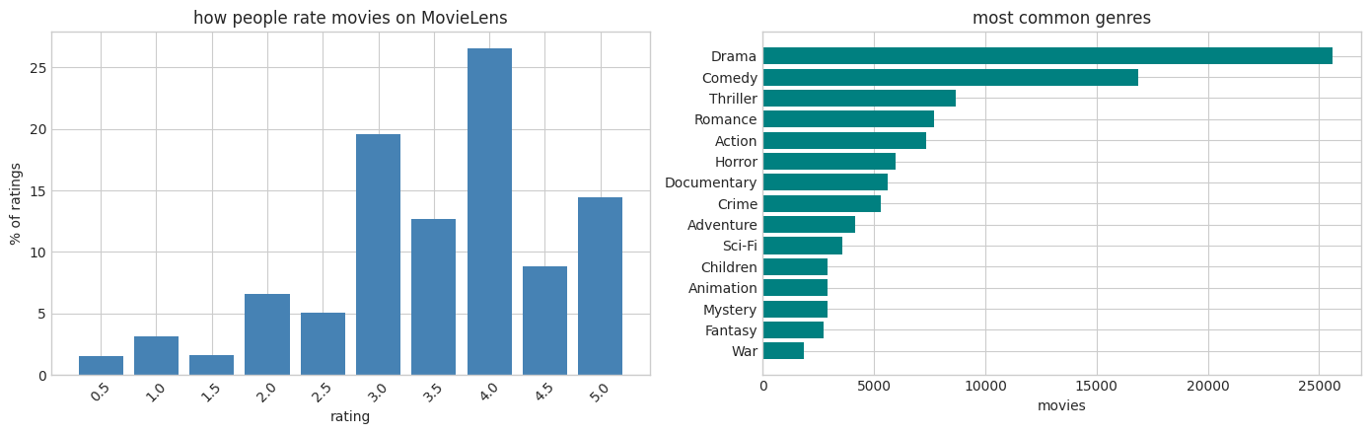
How it works
- Natural Language Processing (NLP) side:
I used a method called Term Frequency-Inverse Document Frequency (TF-IDF). Its a NLP technique which is used to turn text into numbers
For each movie I take details such as plot, keywords, cast, and director, I combine them into a single string. Then TF-IDF reads through all these strings giving each word a score. Words that would appear a lot in one movie but not in other movies get high scores. Words that appear in a lot of the movies would get low scores. For example the word “the” or “and” would be scored low while words like “space, spaceship, or galaxies” would be scored higher. The result ends up being a 61,000 x 49,000 sparse matrix. The rows would be a movie and the column would be a word.
To compare movies I use cosine similarity, a normalized dot product of their rows (movies x words). I would use the cosine similarity to line the scores list and check how well the high scores match. The normalized result is between 0 and 1 where higher means more similar. The reason I chose to do cosine is because when I was researching other models cosine wouldn’t be affected by the length of the text. So a movie with a really long “string” wouldn't have an edge over a movie with a short “string”.
One extra thing that I did to the model was genres and keywords were repeated twice in the “string” because genres and keywords were better for the model vs the plot summaries so I wanted the genres/keywords to have more weight.
- Collaborative Filtering side:
The collaborative filtering side uses ratings instead of text. The way it works is that if a bunch of users in the MovieLens dataset rated the movies I watched highly then their taste in movies was similar to my own. Meaning the movies they rate highly are also probably something I would watch.
So I take the ratings table (162,000 users x 56,000 movies) which were mostly empty because not every user rated every movie. Then I used Singular Value Decomposition (SVD) to compress it. SVD would find 150 hidden taste dimensions. Every user becomes a vector of 150 numbers and every movie also becomes 150 numbers. Using SVD the model would figure out what the dimensions mean on its own. It would be thing such as “this user loves sci-fi or hates horror”.
One of the things I learned while testing my model is I had to use “mean-centering” which is subtracting the average rating from each user. The reason why is because without it the model would only learn that users on average rate everything 3.5 stars instead of learning the differences in taste. While I already had mean-centering my first version has a bug where I was splitting my train and test data by user. Which meant test users had no training data and the model predicted zero for them. my model's Root Mean Squared Error (RMSE) was 3.69 and after I fixed the split I was getting a RMSE of .97. Then I added a few more techniques such as bias correction and bayesian shrinkage and the final RMSE was .85.
The bias correction works by subtracting a per-movie average. Like star-wars gets rated higher than Battlefield Earth no matter who watches so I separate a “universally well-liked movie” from “this movie matches your specific taste”. This is called biased matrix factorization.
I added bayesian shrinkage on the biases. If a movie only has 5 ratings then its bias gets pulled towards 0 because 5 is too small of a sample. I used a base value of 20. Without this, obscure movies that had high ratings would be recommended above other more likely candidates.
Lastly, so I could use this for myself I would find MovieLens users who rated my favorite movies highly. The top 20 users with the most overlap would become my proxy users. I would average their taste vectors into one , and then use that to score every movie.

In the figure below it showcases how much taste info the model captures as more hidden dimensions are added. By dimension 150 it have picked up around 24% of the patterns in the ratings.
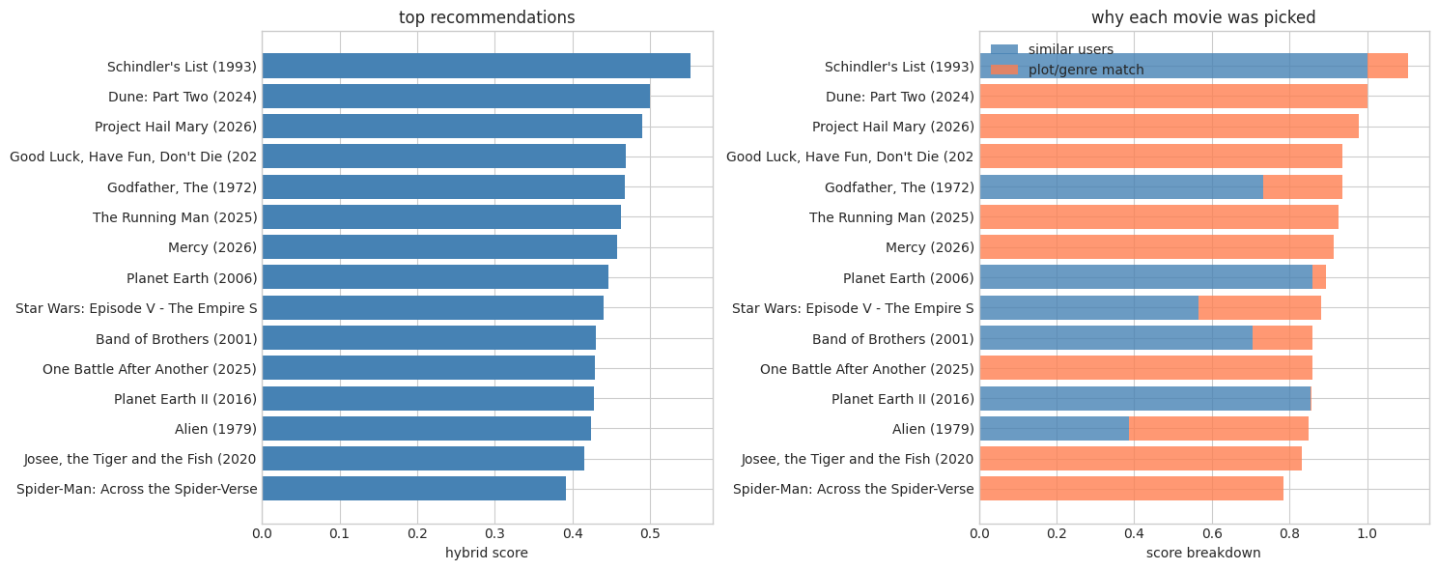
- Hybrid scoring and confidence
Both NLP and Collaborative Filtering give me a score for every recommended movie. I then normalize each to give a 0-1 range and blend both approaches 50/50. So the final model is half content similarity and half collaborative filtering.
Confidence rating for each recommendation is based on two things. How high the hybrid score is within the pool of recommended movies, and whether both signals agree with each other. If both content similarity and collaborative filtering rank a movie high then the confidence is high. If it only does one it's medium or low.
For recent movies that arent in the MovieLens dataset there isnt “ratings” so it only uses content score. So the confidence gets capped at medium because its missing ratings evidence.
I also made sure that any movies in the MovieLens dataset with less than 100 ratings get dropped. This leaves roughly 10,000 movies that are able to be recommended. When I didn’t do this I would get very niche films as recommendations.
Evaluation
To make sure the model was actually learning I separated 20% of the MovieLens dataset for my test set. The model never saw this data during the training. I then would have the model predict what these movies would be rated and measured the RMSE.
I compared these scores against three baselines to prove that its actually working. Always predict the global average rating, always predict each users rating, and use just per-user and per-movie averages with no SVD.
For the results I got an RMSE of 1.0607 on the global mean, an RMSE of .9572 on the Per-user mean, User and movie averages with no SVD had an RMSE of .8768, and the entire model had an RMSE of .8511
The full model beat all the baselines showcasing that the 150-dimension latent factors are actually learning taste patterns not just averages.
Results
Below is a table that showcases the 20 movies that were input into the model and the movies it recommends based on them (the * represents movies that are from TMDb, and are new so they dont use ratings). In this scenario I'm pretty sure the confidence level is low because of the wide range of types of movies and genres.

My 20 Favorite Movies | Top 15 Recommendations
Inception (2010) | Schindler's List (1993) 55% (Medium)
The Dark Knight (2008) | *Dune: Part Two (2024) 50% (Medium)
Interstellar (2014) | *Project Hail Mary (2026) 49% (Medium)
The Matrix (1999) | *Good Luck, Have Fun, Don't Die (2026) 47% (Medium)
Pulp Fiction (1994) | Godfather, The (1972) 47% (Medium)
Fight Club (1999) | *The Running Man (2025) 46% (Medium)
The Lord of the Rings: The Fellowship of the Ring (2001) | *Mercy (2026) 46% (Medium)
GoodFellas (1990) | Planet Earth (2006) 45% (Medium)
Eternal Sunshine of the Spotless Mind (2004) | Star Wars: Episode V - The Empire Strikes 44% (High)
The Social Network (2010) | Band of Brothers (2001) 43% (Medium)
Whiplash (2014) | *One Battle After Another (2025) 43% (Medium)
Parasite (2019) | Planet Earth II (2016) 43% (Medium)
No Country for Old Men (2007) | Alien (1979) 42% (High)
There Will Be Blood (2007) | *Josee, the Tiger and the Fish (2020) 42% (Medium)
Spirited Away (2001) | *Spider-Man: Across the Spider-Verse (2023) 39% (Medium)
Mad Max: Fury Road (2015)
Blade Runner 2049 (2017)
Arrival (2016)
The Grand Budapest Hotel (2014)
Get Out (2017)

However the model also allows singular input and the confidence and recommendation end up much better and you get much better recommendations for your next movie.

Spider-Man (2002) Recommendations
1 | Spider-Man 2 (2004) 94% (High)
2 | Spider-Man 3 (2007) 79% (High)
3 | X2: X-Men United (2003) 74% (High)
4 | Fantastic Four: Rise of the Silver Surfer 66% (Medium)
5 | Superman (1978) 66% (Medium)
6 | Superman Returns (2006) 66% (High)
7 | X-Men (2000) 64% (Medium)
8 | Fantastic Four (2005) 62% (Medium)
9 | Phantom, The (1996) 62% (Medium)
10 | Green Lantern (2011) 62% (Medium)
11 | Captain America: The First Avenger (2011) 61% (Medium)
12 | Spawn (1997) 60% (Medium)
13 | Amazing Spider-Man, The (2012) 58% (Medium)
14 | Hulk (2003) 58% (Medium)
15 | Hellboy (2004) 58% (Medium)

Conclusion
The project works and produces reasonable recommendations. The evaluations show that the model is actually learning the taste patterns rather than just predicting the average. Both systems NLP and collaborative filtering work well and give me great results. If I keep working on this model some things I would work on would be, getting the tracker integration working so I have more input data. Add a way for me to like a movie, currently it just uses my “watched” movies and assumes I liked it based off of that. If I add a system to rate the movies I could get much better recommendations. Another issue is that my wife and I use the same account and our taste are different. So we are seen as 1 user and it messes with the model's output. Also after the girls presented in class I could replace the TF-IDF with BERT this would help gather meaning rather than overlap. Currently my model just sees if the words are similar between one movie vs another where BERT would let me actually compare meaning. Another problem with my model is a new user would have 0 watch history so the recommendations will pretty much be random. I could take the netflix approach and survey the user on the movies they like and use that as a baseline.

